**PROJECT REPORT**

Of

**Six Weeks Industrial Training**

On

**“Online Food Ordering”**

At

**SLICKSOFT TECHNOLOGIES R&D Pvt. Ltd.**

**Submitted By-**

**Puneet Kumar**

**Roll No. 11501095**

3CE-3

Semester-5



**DEPARTMENT OF COMPUTER ENGINEERING**

**Punjabi University, Patiala-147002**

**Punjab (India)**

|  |
| --- |
| **PREFACE** |

This work has been done as a part of industrial training. The purpose of industrial training is to familiarize the students with the present working environment in country and outside.

To provide the students with the opportunity to study the latest technical trends those have been established as well as one that what they are learning during the period of industrial training will certainly help them to develop their potential and technical skills.

As part of our industrial training I undertook a project of **“Online Food Ordering”** which will be useful for the users in online food ordering. We also undertook classes of JAVA during our training where we learnt how an actual project progress and what sort of problems that actually occur throughout the development of project.

|  |
| --- |
| **ACKNOWLEDGEMENT** |

“*No work is considered complete unless due acknowledgement is given to those who made the work possible.*”

The past six weeks has been a gratifying experience for me and have brought me in contact with professionals who have positively contributed to my vision, knowledge and understanding of the technical and social aspects of software engineering.

It is my privilege to acknowledge with the deepest sense of gratitude, the keen personal interest and invaluable guidance goes to my guide Mr. Gurpreet Singh Khanna for his support, encouragement and help at every stage of project, while I faced any problem regarding my project of “**Online Food Ordering**”. This work simply would not have reached up to such extent without his cognitive and rational guidance and guidelines.

Finally, I am indebted to all those who directly or indirectly contributed for making this project a reality.

|  |
| --- |
| **CERTIFICATE OF TRAINING** |

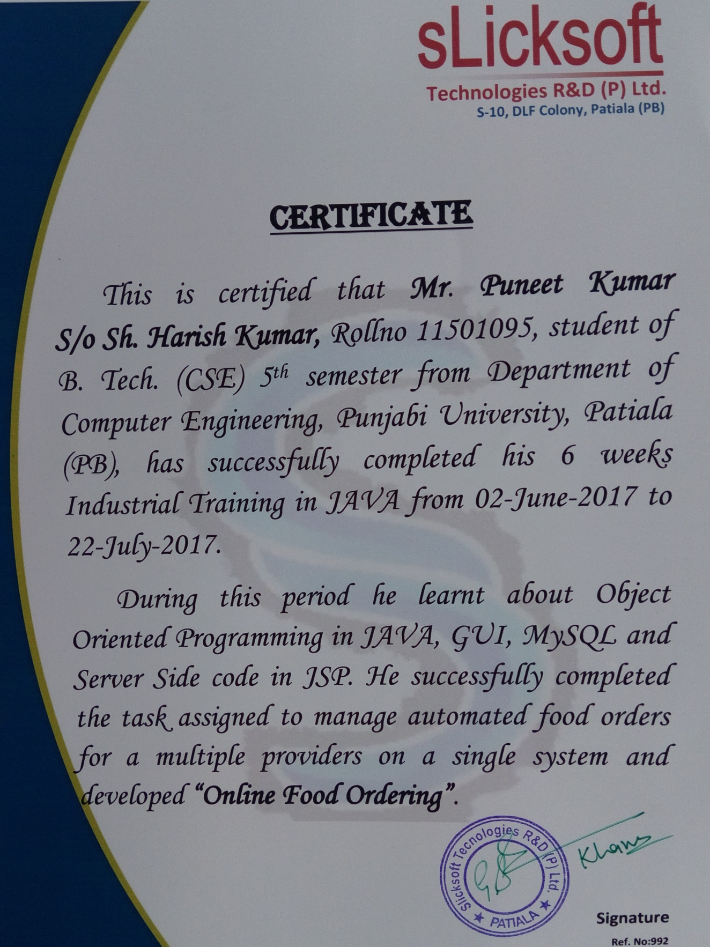

|  |
| --- |
| **TABLE OF CONTENTS** |

|  |  |
| --- | --- |
| **Description** | **PageNo** |
| * PREFACE | I |
| * ACKNOWLEDGEMENT | Ii |
| * CERTIFICATE | Iii |
| * COMPANY’S PROFILE | 1 |
| * INTRODUCTION TO TECHNOLOGY USED IN PROJECT | 3 |
| * PROJECT – ONLINE FOOD ORDERING | 17 |
| * SCREENSHOTS | 28 |
| * TESTING | 45 |
| * REQUIREMENT ANALYSIS | 46 |
| * BIBLIOGRAPHY | 47 |

***COMPANY’S PROFILE***

**About us**

"As a software consultancy and R&D firm, offering top notch solutions to all business and customer needs delivering quality product/services. In the fields of software design and development, content management e-commerce solutions, web based applications using high end open source technologies."

SlickSoft Technologies R&D Pvt. Ltd. is committed to provide world class softwares in the region. With the time it has become a well known ISO Certified IT Development and Learning Center.

**Vision**

“To be the leaders in providing turnkey consulting and solutions implementing suitable high end technologies, focusing the customer business needs, dealing in best of breed product engineering life cycle solutions to the global software development and IT industry.”

“At SlickSoft Technologies R&D Pvt. Limited, we measure our amplitude with our success. Projecting ourselves as forward looking company and helping to pave the way offering 360 degree wide spectrum solutions in the global market especially contributing to our Indian industry. Among the rising IT and R&D software services company combining trusted cutting edge technology with business acumen to deliver with quality , innovative web solutions , engineering consultancy and in the fields of software design and development, content management solutions, e-commerce solutions and web application development also providing web hosting and domain”.

**Mission Statement**

Our mission and values are to help people and business throughout to realize their full potential.

And "To achieve our objective in an environment that fosters honesty in reliability, fairness and integrity and a single minded focus on the success of our customers and our enterprise".

**Professional Services**

* SMS Gateway and Bulk SMS Services
* Software & Web Development
* Software Testing
* Domains and Hosting

**For Students**

* **Industrial training on live projects**: In today´s world, the success or failure of industrial companies and entire economies depends on the availability of first-class specialists. Skilled staff that is able to meet the ever-changing and ever-increasing challenges in the modern industrial age. SLICKSOFT TECHNOLOGIES R&D Pvt. Ltd. training concept is modular, offering the flexibility you need to set up your own custom training solutions for each and every requirement, all levels, and almost any budget.
* With the subject wise practical information to Engineering students, We provide in-depth knowledge of Languages and Database handling, Hardware Interaction at the student and professional level and involve them in implementation of various projects for electronics and Computer trade. SlickSoft Technologies is IT learning Solutions and is known for its pioneering work in the field of IT education and training in the region. Our strong research orientation has helped us continuously innovate in the areas of Education and Software development methodologies. **Our trainers** provide a comprehensive education environment to individuals, offerings training that is customized to the varied needs of industries with diverse backgrounds. SlickSoft has trained many software professionals in the region who are now parts of big multinational IT-Solution companies.

**INTRODUCTION TO TECHNOLOGY USED IN PROJECT**

The system developer’s task is to view needed capabilities in light of currently available technology. Our site works hand in hand with high technology. A database has to be maintained in order to update and backup data whenever required. To create database I use SQL server. After taking the above facts into consideration I can state that the new proposed system is technically feasible. As the software is very much economically feasible, then it is really important for it to be technically sound. The software will be build among:

**Front-end**

HTML 5, JavaScript, Java, JSP

**Back-end**

MICROSOFT SQL SERVER

**FRONT-END**

Front end consists of the following:-

**HTML 5**

HTML5 is the latest standard for HTML. The previous version of HTML, HTML 4.01, came in 1999, and the internet has changed significantly since then.HTML5 was designed to replace both HTML-4, XHTML and the HTML DOM Level 2.

It was specially designed to deliver rich content without the need for additional plugins. The current version delivers everything from animation to graphics, music to movies, and can also be used to build complicated web applications.

HTML5 is also cross-platform. It is designed to work whether you are using a PC, or a Tablet, a Smartphone, or a Smart TV.

HTML5 is a co-operation between the World Wide Web Consortium (W3C) and the Web Hypertext Application Technology Working Group (WHATWG). WHATWG was working with web forms and applications, and W3C was working with XHTML 2.0. In 2006, they decided to cooperate and create a new version of HTML.

Some rules for HTML5 were established:

* New features should be based on HTML, CSS, DOM, and JavaScript.
* The need for external plugins (like Flash) should be reduced.
* Error handling should be easier than in previous versions.
* Scripting has to be replaced by more markup.
* HTML5 should be device-independent.
* The development process should be visible to the public

**HTML TAGS:**

**<html>:**

Represents the root of an HTML or XHTML document. All other elements must be descendants of this element.

**<head>:**

Represents a collection of metadata about the document, including links to, or definitions of, scripts and style sheets.

**<title>:**

Defines the title of the document, shown in a browser's title bar or on the page's tab. It can only contain text and any contained tags are not interpreted.

**<style>:**

Used to write inline CSS.

**<body>:**

Represents the content of an HTML document. There is only one <body> element in a document.

**<header>:**

Defines the header of a page or section. It often contains a logo, the title of the Web site, and a navigational table of content.

**<footer>:**

Defines the footer for a page or section. It often contains a copyright notice, some

links to information, or addresses to give feedback.

**<p>:**

Defines a portion that should be displayed as a paragraph.

**<hr>:**

Represents a thematic break between paragraphs of a section or article or any longer content.

**<ol>:**

Defines an ordered list of items.

**<ul>:**

Defines an unordered list of items.

**<br>:**

Represents a line break.

**<img>:**

Represents an image tag.

**<table>:**

Represents data with more than one dimension.

**<tr>:**

Represents a row of cells in a table.

**<td>:**

Represents a data cell in a table.

**<th>:**

Represents a header cell in a table.

**<form>:**

Represents a form, consisting of controls, that can be submitted to a server for processing.

**JAVA SCRIPT**

A scripting language is a lightweight programming language. JavaScript code can be inserted into any HTML page, and it can be executed by all types of web browsers. JavaScript is easy to learn. JavaScript is the language for the web, for HTML, for servers, PCs, laptops, tablets, cell phones, and more.

JavaScript is not a programming language in strict sense. Instead, it is a scripting language because it uses the browser to do the dirty work. If you command an image to be replaced by another one, JavaScript tells the browser to go do it. Because the browser actually does the work, you only need to pull some strings by writing some relatively easy lines of code. That’s what makes JavaScript an easy language to start with.

But don’t be fooled by some beginner’s luck: JavaScript can be pretty difficult, too. First of all, despite its simple appearance it is a full fledged programming language: it is possible to write quite complex programs in JavaScript. This is rarely necessary when dealing with web pages, but it is possible. This means that there are some complex programming structures that you’ll only understand after protracted studies.

Secondly, and more importantly, there are the browser differences. Though modern web browsers all support JavaScript, there is no sacred law that says they should support exactly the same JavaScript. A large part of this site is devoted to exploring and explaining these browser differences and finding ways to cope with them.

**Features**

* JavaScript was designed to add interactivity to HTML pages.
* JavaScript is a scripting language.
* A scripting language is a lightweight programming language.
* A JavaScript consists of lines of executable computer code.
* A JavaScript is usually embedded directly into HTML pages.
* JavaScript is an interpreted language (means that scripts execute without preliminary compilation).
* Everyone can use JavaScript without purchasing a license.

**INTRODUCTION TO JAVA**

**Java** is a programming language originally developed by Sun Microsystems and released in 1995. James Gosling, Patrick Naughton, Chris Warth, Ed Frank and Mike Sheridan developed Java at Sun Microsystems, Inc. in 1991. This Language was initially called “Oak” but was renamed “Java” in 1995.

The language derives much of its syntax from C and C++ but has a simpler object model and fewer low-level facilities. From C, Java derives its syntax. Many of Java’s object oriented features were influenced by C++. The major feature of Java is that it is **platform independent.** Java applications are typically compiled to bytecode that can run on any Java virtual machine (JVM) regardless of computer architecture.

**Java Features:**

1. **Platform Independent:** The *Write-Once-Run-Anywhere* ideal has not been achieved (tuning for different platforms usually required), but closer than with other languages.

**2. Object Oriented:** Java is pure object oriented throughout i.e. there is no coding outside of class definitions, including main(). There is an extensive class library available in the core language packages.

**3. Compiler/Interpreter Combo:** Code is compiled to bytecodes that are interpreted by a Java virtual machines (JVM). This provides portability to any machine for which a virtual machine has been written. The two steps of compilation and interpretation allow for extensive code checking and improved security.

**4. Robust:** Exception handling built-in, strong type checking (that is, all data must be declared an explicit type), local variables must be initialized.

**5. Several Dangerous Features of C and C++ Eliminated:** No memory pointers are used. No preprocessors defined. Array index limit checking.

**6. Security:**

* No memory pointers.
* Programs run inside the virtual machine sandbox.
* Array index limit checking

**7. Dynamic Binding:** The linking of data and methods to where they are located, is done at run-time. New classes can be loaded while a program is running. Linking is done *on the fly*. Even if libraries are recompiled, there is no need to recompile code that uses classes in those libraries. This differs from C++, which uses static binding. This can result in *fragile* classes for cases where linked code is changed and memory pointers then point to the wrong addresses.

**8. Good Performance:** Interpretation of bytecodes slowed performance in early versions, but advanced virtual machines with adaptive and just-in-time compilation and other techniques now typically provide performance up to 50% to 100% the speed of C++ programs.

**9. Threading:***Lightweight* processes, called threads, can easily be spun off to perform multiprocessing. We can take advantage of multiprocessors where available. It is great for multimedia displays.

**10. Built-in Networking:** Java was designed with networking in mind and comes with many classes to develop sophisticated Internet communications.

Features such as eliminating memory pointers and by checking array limits greatly help to remove program bugs. These and the other features can lead to a big speedup in program development compared to C/C++ programming.

**JAVA PLATFORM**

A *platform* is the hardware or software environment in which a program runs. Most platforms can be described as a combination of the operating system and hardware. The Java platform differs from most other platforms in that it's a software-only platform that runs on top of other hardware-based platforms.

The Java platform has two components:

* The***Java Virtual Machine* (**Java VM**)**
* The***Java Application Programming Interface* (**Java API**)**

***Java Virtual Machine* (**Java VM**)**

Java Virtual Machine is standardized hypothetical computer, which is emulated inside our computer by a program. It is base of Java platform and is ported onto various hardware-based platforms. JVM stands for Java Virtual Machine. All language compilers translate source code into machine code for a specific computer. Java compiler also does the same thing. It provides an intermediate code known as BYTE CODE for a machine that does not exist. This machine is called Java Virtual Machine and resides only inside the computer’s memory.

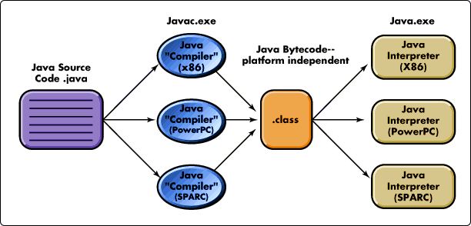

The virtual machine code is not machine specific. The machine specific code (known as machine code) is generated by Java Interpreter by acting as intermediately between virtual machine and real machine as shown if figureabove.

**Byte Code:** Byte code is the key that allows java to solve both security and portability problems. Byte code is a highly optimized set of instructions designed to be executed by java runtime system (i.e. JVM). In essence, JVM is an interpreter for Byte code. As the Byte code is highly optimized, the use of byte code enables JVM to execute programs much faster than we expect.

Translating a java program into Byte code makes it much easier to run a program in a wide variety of environments. Byte code is also referred to as Virtual Machine code.

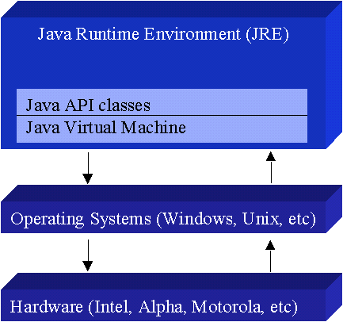

The Java API is a large collection of ready-made software components that provide many useful capabilities, such as graphical user interface (GUI) widgets. The Java API is grouped into libraries of related classes and interfaces; these libraries are known as packages.

**Garbage Collection**: Garbage Collection is a good way to free programmers from the burden of having to explicitly free the allocated memory. On execution a Java programme creates and uses different objects. Each object within a programme uses some amount of system resources such as system memory during runtime. Garbage collection is the process that is used to free the memory of the objects that are no longer in use. The garbage collection is done automatically for you by the system.

**Java Program**: Each Java program defines a class. The name of class is same as that of name of .java file in which this source program is to be stored. For core java, there must exist a public function named “main”, receiving command-line-arguments as an array of String class. This member method will be executed when java program is executed. As every java program is definition of a class, therefore, during the execution an object of this class is automatically created and executed “main” method on that object.

We cannot execute a java program without class which makes it “pure-object-oriented”. In C++, it supported the object-oriented techniques, but itself C++ was not a pure-object-oriented language because C++ used the procedure “main ( )” as startup method/function, which was not a member of any class. Therefore, it was a procedural language because the program starts from a procedure, now, objects can be declared and used within that procedure but the still it a procedure that invoked the code.

Java Virtual Machine is standardized hypothetical computer, which is emulated inside our computer by a program. It is base of Java platform and is ported onto various hardware-based platforms.

The Java API is a large collection of ready-made software components that provide many useful capabilities, such as graphical user interface (GUI) widgets. The Java API is grouped into libraries of related classes and interfaces; these libraries are known as *packages*.

**Java Environment**

Java environment includes large number of development tools and hundreds of classes and methods. The development tools are part of the system known as *Java Development Kit* (JDK) and the classes and methods are part of the *Java Standard Library* (JSL), also known as the *Application Programming Interface* (API).Some of the basic concepts of Core Java are

* **main() method**
* in Java, the main() method and the class in which it is defined should be declared public because the Java runtime environment has to access the main() method to execute a program
* The main () method should be declared static because it has to exist before any object of the class is created.
* The command line parameter is a String type variable – main(String args[]). The number of arguments is determined by the String class object.
* **Access specifiers** used by java are public, private and protected.
* Variables, methods and blocks can be declared as **static**. The concept behind static is that only one copy of it exists. There is no concept of static classes.
* **Execution of program**
* Save the file with file_name.java
* Go on command prompt.
* **javac**file_name.java. <Enter>
* **java** file_name<Enter>
* **Interfaces**
* Are set of abstract methods.
* They are used to provide the concept of multiple inheritance.
* They are used for implementing inheritance relationship between non-related classes.
* Keyword used for inheriting interfaces is **implements.**
* **Hybrid inheritance** is possible through interfaces.
* A class can extend only single class but can implement many interfaces.
* Syntax: **class**class_name**implements**interface_name
* **Packages**
* Java uses packages to organise related classes.
* Different packages can have classes with same name.
* They have hierarchical structure.
* Java uses **import** statement to use packages in a program.

Syntax: **import**<package_name>.*;

**import**<package_name>.<class_name>;

* **Inbuilt packages**
* **java.awt – Abstract Window Toolkit.** Contain all graphics related classes.
* **javax.swing -** Extension of awt. (javax is java extended). Provides component classes like JLabel, JTextField, JButton and JComboBox.
* **java.awt.event –** sub-package of awt. Used for event handling(like action on button-clicking.
* **java.sql –** Conatins database handling related classes.
* **java.util –** Contains all the collection related classes.
* **java.lang –** it is by default imported in each and every class.
* **Exception handling:** An **exception** is an abnormal condition that arises in a code sequence at run time. In other words, an exception is a run-time error. In computer languages that do not support exception handling, errors must be checked and handled manually—typically through the use of error codes, and so on. This approach is as cumbersome as it is troublesome. Java’s exception handling avoids these problems and, in the process, brings run-time error management into the object-oriented world. Java has Exception class which is root class to all the exception classes.

Some of the exceptions are:

* **ArithmeticException**
* **ArrayIndexOutOfBoundException**
* **NullPointerException –** When the object contains null reference and even then we are calling some member using it.
* **Exception handling techniques**
* **try-catch block –** try block contains suspected statements that can generate exceptions.
* **throw -** if we know there can be an exception, we can throw it.

Syntax: **throw** new ArithmeticException();

* **throws –** this can be used only with methods. This is applied when user do not want to handle checked exceptions( exceptions which if not handled will give compilation errors)

Syntax**:** public static void main(String args[]) **throws exception**

* **user defined exceptions -** They are created by extending the Exception class.

The throw and throws keywords are used while implementing user-defined exceptions.

* **Multi-threading**
* The **java.lang.Thread** class is used to construct and access the individual threads in a multithreaded application.
* A process having more than one thread is said to be multithreaded. The multiple threads in the process run at the same time, perform different tasks, and interact with each other.
* 2 ways to create threads:
* by extending the Thread class:-Syntax: public class <class_name> extends Thread
* by Runnable Interface:- The Runnable interface consists of a single method run(), which is executed when the thread is activated

**Java awt class hierarchy:**The Java AWT (Abstract Windowing Toolkit) contains the fundamental classes used for constructing GUIs. The abstract Component class is the base class for the AWT. Many other AWT classes are derived from it. Button, Canvas, and Container are some AWT classes derived from Component. The JComponent class is derived from Container and is one of the base classes of Swing. The JFrame class is derived from the AWT Frame class. It is usually the main container for a GUI application. The JApplet class (derived from the AWT Applet class) is sometimes used for Web programming, but the Applet class is more frequently used.

**Java swings class hierarchy**Swing is a set of classes that provides more powerful and flexible components than are possible with the AWT. In addition to the familiar components, such as buttons, check boxes, and labels, Swing supplies several exciting additions, including tabbed panes, scroll panes, trees, and tables. Even familiar components such as buttons have more capabilities in Swing. For example, a button may have both an image and a text string associated with it. Unlike AWT components, Swing components are not implemented by platform-specific code. Instead, they are written entirely in Java and, therefore, are platform independent. The Swing-related classes are contained in **javax.swing**. Some of the classes used are JApplet, JLabel, JButton, JScrollPane, JTextArea, JTextField, JMenuBar, JMenu, JFrame. JApplet and JFrame provides a method getContentPane() which returns a reference to their associated content pane. So to get a reference to the JApplet’s container where user will add their GUI objects. A brief description of the components of swing class is as follows:

**JPanel** is Swing's version of the AWT class Panel and uses the same default layout, FlowLayout. JPanel is descended directly from JComponent.

**JFrame** is Swing's version of Frame and is descended directly from that class. The components added to the frame are referred to as its contents; these are managed by the contentPane. To add a component to a JFrame, we must use its contentPane instead.

**JDialog**contains a rootPane hierarchy including a contentPane, and it allows layered and glass panes. All dialogs are modal, which means the current thread is blocked until user interaction with it has been completed. JDialog class is intended as the basis for creating custom dialogs; however, some of the most common dialogs are provided through static methods in the class **JOptionPane**.

**JLabel**, descended from JComponent, is used to create text labels.

**JTextField** allows editing of a single line of text. New features include the ability to justify the text left, right, or center, and to set the text's font.

**JPasswordField** (a direct subclass of JTextField) you can suppress the display of input. Each character entered can be replaced by an echo character. This allows confidential input for passwords, for example. By default, the echo character is the asterisk, *.

**JTextArea** allows editing of multiple lines of text. JTextArea can be used in conjunction with class JScrollPane to achieve scrolling. The underlying JScrollPane can be forced to always or never have either the vertical or horizontal scrollbar;

**JButton** is a component the user clicks to trigger a specific action.

**JRadioButton** is similar to **JCheckbox**, except for the default icon for each class. A set of radio buttons can be associated as a group in which only one button at a time can be selected.

**JCheckBox** is not a member of a checkbox group. A checkbox can be selected and deselected, and it also displays its current state.

**JComboBox** is like a drop down box. You can click a drop-down arrow and select an option from a list. For example, when the component has focus, pressing a key that corresponds to the first character in some entry's name selects that entry. A vertical scrollbar is used for longer lists.

**JList** provides a scrollable set of items from which one or more may be selected.

**FlowLayout** when used arranges swing components from left to right until there's no more space available. Then it begins a new row below it and moves from left to right again. Each component in a FlowLayout gets as much space as it needs and no more.

**BorderLayout** places swing components in the North, South, East, West and center of a container. You can add horizontal and vertical gaps between the areas.

**GridLayout** is a layout manager that lays out a container's components in a rectangular grid. The container is divided into equal-sized rectangles, and one component is placed in each rectangle.

**BACK END**

**Java Database Connectivity: JDBC** is an API for the Java programming language that defines how a client may access a database. It provides methods for querying and updating data in a database. JDBC is oriented towards relational databases.

JDBC was first introduced in the Java 2 Platform, Standard Edition, version 1.1 (J2SE), together with a reference implementation JDBC-to-ODBC bridge, enabling connections to any ODBC-accessible data source in the JVM host environment.

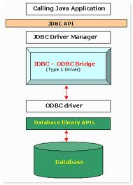

**SQL (STRUCTURED QUERY LANGUAGE)**

**SQL** (**Structured Query Language**, is a database computer language designed for the retrieval and management of data in relational database management systems (RDBMS), database schema creation and modification, and database object access control management.

The SQL language is sub-divided into several language elements, including:

* Statements which may have a persistent effect on schemas and data, or which may control transactions, program flow, connections, sessions, or diagnostics.
* Queries which retrieve data based on specific criteria.
* Expressions which can produce either scalar values or tables consisting of columns and rows of data.
* Predicates which specify conditions that can be evaluated to SQL three-valued logic (3VL) Boolean truth values and which are used to limit the effects of statements and queries, or to change program flow.
* Clauses which are in some cases optional, constituent components of statements and queries.
* Whitespace is generally ignored in SQL statements and queries, making it easier to format SQL code for readability.
* SQL statements also include the semicolon (";") statement terminator. Though not required on every platform, it is defined as a standard part of the SQL grammar.

**Features of MySQL Graphical User Interface:**

* Information representation.
* Unique definition of rows.
* Systematic treatment of Null values.
* High level Update, Insert, and Delete.
* Retrieving information from the database.
* Accepting query language statements.

***PROJECT UNDERTAKEN***

The project **Online Food Ordering** is a web based project. The main objective of this application is to enhance and personalize the customer experience. The customer can shop food online and deliver at the door step. There are basically three modules i.e. **Admin Module**, **Customer Module** and the **Restaurant Module**. The Admin manage the database of the project through admin module. The restaurant can add their menu along with price. The restaurant can see the feedback given by the customer and improve them and expand their business. Moreover restaurant can see the pending orders so that they can deliver it on time. Any restaurant can register us free of cost and online their business. The restaurant provide menu of food from which the user can choose from. The user can also create a account free of cost and can order food from the nearby registered restaurant. The user can also keep their order in the cart. The user can also give feedback to the restaurant about their food or facilities. There is also an option of blog. Users can add their ideas in the blog and other user can see that. In this payment is done via COD(cash on delivery).

**Complete Objective**

The main objective of this project **Online Food Ordering** is to provide information to current and potential clients and to promote and market the organization. The users can shop while in the comfort of their home, without having to step out of their door and get products in accordance to their requirement at cheap and affordable price. User can buy food at any time according to the need. In this system, there is a registration process for users. To use the services of this system one has to go to the website concerned and in just no time one can access as many food as one wants. Starting from home page one can get full information about the food selected and can confirm their order.

The project has Three main modules:

1. **User Module**

* Buyers
* Guests

1. **Administrator or Admin Module**

**MODULAR DESCRIPTION OF PROJECT- ONLINE FOOD ORDERING**

1. **Restaurant Module**

* Seller
* Guests

Project contains the following modules:

**ADMIN MODULE:**

Administrator is a person responsible for maintaining one or many websites. The duties of the web admin may include ensuring that the web servers, hardware and software are operating correctly, designing the website, generating and revising web pages. Administrators perform administrative duties and co-ordinate activities related to the management and updating of a website. In our website there are many admins which are handling the site. They have privileges such as-

* View User
* Active/Inactive User
* View Restaurant
* Active/Inactive User
* Delete User
* Delete Restaurant
* Add Admin
* Remove Admin
* Add blog
* View & Edit Notice
* View Queries & Complaints

**USER MODULE:**

User module is mainly Sub divided into 2 modules:

**Guest Module:**

Whosoever opens our site is guest user until he/she gets registered. Guest users can view all the blogs on the site but they must register first to buy food from the site.

**Buyer Module:**

A user can acts as buyer. Users can register themselves for free by just providing their contact details. User can choose between the restaurants that is best suites them. From the chosen restaurant we can see the menu of the restaurant. From the menu we can choose the food that we want to eat and add that food into the cart and order. Payment can be done in offline way i.e. Cash on Delivery (COD). Hence, in this way the users can get food as per their requirement at an their door step.

Certain functions which user can perform are given below:-

* Change Profile
* View Profile
* View Restaurant
* Search Restaurant
* View menu
* Give Feedback
* Add Blog
* Edit/delete Blog
* View Cart
* Order Food

**RESTAURANT MODULE:**

User module is mainly Sub divided into 2 modules:

**Guest Module:**

Whosoever opens our site is guest user until he/she gets registered. Guest restuarant can view all the blogs on the site but they must register first to sell food from the site.

**Seller Module:**

Restaurants basically act as seller. Restaurants can add their menu items and may modify it. Restaurant can view order so that they can deliver it at their doorstep. Payment is basically done through the COD (cash on delivery). Restaurant also see the feedback give by the users and can improve them.

Certain functions which user can perform are given below:-

* Add Menu
* Modify Menu
* View Feedback
* Pending Orders
* Search menu

**Detailed Description of HomePage**

Whenever a person visits the website, he/she will see the homepage first where there will be many options such as Home, User login, admin login, Restaurant login, New user login, New restaurant Signup, View Blog, Contact us and About Us.

* **Home** - It contain information about the maker of the website and can contact us at facebook, instagram or twitter.
* **User Login**- This option is for user to login into their accounts and avail various facilities provided by our site.
* **Admin Login-** This option is for admin to login into their accounts and manage the site. This is placed here for demonstration purpose only when this site will be uploaded to server admin will only will able to login via URL.
* **Restaurant Login-** This option is for Restaurant to login into their accounts and avail various facilities provided by our site.
* **View Blog**- Here any user can see the blog written by the register user.
* **Register-**This option is for users through which user can register for the site and able to shop from the site.
* **Contact us**-This option is used to describe contact information for the site..
* **About us**- This option will show details about the developers for the site.

**SECURITY:**

Security is concerned with making sure that unauthorized people cannot access the software. Even no one can change the entered information of products. Security requirements are particularly significantly in many database systems. Security requirements lace restrictions on the use of certain commands, control access to data, provide different kinds of access requirements for different people, require the use of password.

If the person signs in, then first of all the site will check if the username and the password entered by the user are correct and whether the user is an active user or not. If the details are verified, only then user can proceed else an alert will be shown.

Now, suppose that user has signed in. He/She will be able to post blog by entering details and can also purchase food from different restaurant. He/She can also be able to check her/his cart i.e. the items selected to be purchased. He/She can also file complaints which will be checked by restaurant and they will work over them. User can also see the status of their query that whether it is resolved or not. Every login session expires automatically after twenty minutes if the useror admin forgets to logout. After logging out, one can’t go to the pages visited earlier (those that require logging in).

**NEED:** This project is basically a need of today because everyone is very much busy in their lives and needs everything at his/her fingers. It is a newly enhanced Automated Unified System offering convenience and flexibility. The paper work is reduced and hence the efficiency of the system has been increased.

**INDUSTRY APPLICATION:** There are many direct and indirect applications of such a project in the IT industry. The owner of the Shop can be thought of as a client or user and I can be thought of as an engineer who has to implement the project. The project development took place step by step following the phases of the **Software Development Life Cycle**.

**PURPOSE:** The purpose of this document is to describe the external requirements of the Online Food Ordering Management System project. It also describes the interface for the system. The SRS i.e. System Requirement Specification is a document that completely describes what the proposed software should do without describing how the software will do it.

**SCOPE:** This document is the only one that describes the requirements of the Online Food Ordering Management System. It is basically meant for use by the developers and will be basis for validating the final developed system. Any change made to requirements in the future will have to go through a formal change approval process. The developer is responsible for asking clarification, where necessary, and will not make any alterations without the permission of the client.

**Developer’s Responsibilities Overview:** The developer is responsible for:

* Developing the system.
* Installing the software on the client’s hardware.
* Conducting any user training that might be needed for using the system.
* Maintaining the system.

**Aims & Objectives of the Project:**

* The main objective of this project is to computerize the current manual system of keeping the records of the users.
* To design a system in such a way that even a non-technical person can use it.
* To make software user-friendly.
* To prevent physical loss of data, that is possible in manual system.
* To provide information instantly, whenever it is needed.

**Future Perspective of the project:**

* The project will help the user to get everything online instead of visiting Shops again and again.
* The project will replace the paper work by storing the information or maintaining the database in the computers.
* The project will help the administrator to easily assign authority by computer instead of manually. By this administrator easily can put restrictions on users.

**ACCEPTANCE CRITERIA:**

Whenever we develop any application we always move by keeping an acceptance creation in our mind. Its importance cannot be neglected since the new system that is developed is always evaluated according to specifications made in any acceptance criteria. The basic specification that are included in any acceptance criteria are like minimum resource usage, minimum time taken and maximum output. Speaking generally following are the main acceptance criterion.

The system must reflect the structure of the application it is going to serve with well-defined structure processes.

System must be able to pass various tests performed in testing stage, like about system functions, various options provided by the system, giving desired result at different inputs, its execution time, its response time, its throughput etc.

The system should satisfy the standards and requirements of good software. A few of them are:

**User Friendly:** The software must be user friendly in the sense that any user can understand and work on it easily.

**Time Element:** The system must respond in minimum time i.e. its execution time must be as little as possible.

**Integrity:** The output given by the system should be accurate and reliable.

**Modularity:** The software should be modular so that if a need for any change arises in the future then it should not require too much of the effort and change in one module should not affect the other module.

**Generality:** The application should be general one so that even the person who has not developed this application should be able to make the required modification.

**Transparency:** The application should be transparent in nature so that the person, who has to modify it should be able to understand it. For this, proper documentation can be very helpful. Program abstracts i.e. short written information about the program can be provided separately in manuals.Thus, any Shopping site has to follow the above written criteria. It has its own acceptance criteria which includes the following:

* The data of users should be inserted to database successfully.
* The already existing data can be updated whenever required.
* The stored information can easily be read or retrieved by the user.
* Login assistance for the user to keep their data under security.
* Customize error handling will help them to find and correct the error easily.

**Login Assistance:** When the user login’s, they may forget their password. So for that they must contact to administrator. Each user has their own authority to access the data.

**Reliability:** Reliability is an important factor to make the project trustable. Some issues should be considered as following:

* **Availability**: This software should be available for 24 hours so that whenever users like to buy a product or want to see that, he or she can.
* **Accuracy:** The amount of data stored in database should be 100% accurate.
* **Bugs or Defect Rate:** No critical bugs that cause data loss or system crashes are allowed. Minor bugs that cause interface is messed are allowed. No bugs allowed in transaction of database.
* **Performance:** The project should have capability to deal with requests from number of users per day. Some performance requirements are stated below:
* Response time for a transaction depends on processor speed, I/O speed and network speed. Not considering the network speed, the back-end system should response a transaction less than 1second.
* The system can deal with one hundred applications per second.
* User can login simultaneously to systems with different function accessibility.
* Resource utilization, memory>512 MB, disk>80 GB, communications with other system with high-speed network.
* **Supportability:** Platform, web server, database can be chosen by students, thus they can use any system configurations to fill out the forms.
* **Interfaces:** The automation is system that communicates with users as well as other systems, interfaces must be provided as following:
* **User interfaces:** Interface between Buyers and Sellers.
* **Hardware Interfaces:** The communication between systems depends on the high speed networks.TCP/IP is used as network protocol.
* **Software interfaces:** MySQL acts as interface between the project and database.

**DESCRIPTION OF PRESENT SYSTEM**

Existing system refers to the system that is being followed till now. Presently people go to Restaurants or hotel to purchase food. If a person wants to buy a any kind of food then he/she has to wait in the long quene. He/she has to go to far places to purchase. Depending on your schedule, a restaurant hours might prove to be very inconvenient. Some restaurants open late in the morning and close before the average person gets home from work. The main disadvantage is that there will be lot of difficulties for the citizens as there are distance restrictions. Essentially, you’re stuck with what’s provided in their area.

**LIMITATIONS OF EXISTING SYSTEM**

* Time consuming.
* Limited Choices.
* Depending on your schedule, a restaurant’s hours might prove to be very inconvenient. Some restaurant open late morning and close before the average person gets home from work. Luckily, the Internet never opens or closes.
* There are distance restrictions. Most people would stay away from the prospect of driving out of their city to shop for a new pair of shoes. Essentially, you’re stuck with what’s provided in your area.
* To avoid all these limitations and make the working more accurately the system needs to be computerized.

**PROPOSED SYSTEM -Online Food Ordering**

**Online shopping** is a form of electronic commerce which allows consumers to directly buy food from a restaurant over the Internet using a web browser. It is a system that enable customer of food to place their order online at any time and any place. The reason to develop the system is due to the issues facing by the food industry. These issues are such as peak hour-long queue issues, increase of take away food than visitors, speed major requisite of food preparation. Therefore, this system enhances the speed and standardization of taking the order from the customer and display it to the staff in the kitchen accordingly. At the same time boost up market share for food restaurant and increase return on investment for the investor. The structured methodologies have been chosen to develop the Online Food Ordering.

**Advantages of Online Sell & Purchase (OSP)**

Ordering food online has enhanced convenience by enabling customers to order wherever they want using whichever device they choose. Apart from bringing convenience to customers, restaurants also reap many benefits from having an online food ordering system. Several of these benefits include:

# **1) Enhanced Efficiency:** Having online orders can make the day to day operations more efficient for a restaurant. The time employees use to receive orders through the telephone is reduced and this increases the time employees have to focus on dine-in customers. Possible cases of errors happening when an order is made due to miscommunication or human error are reduced meaning there are no expensive re-deliveries. When a customer makes an order online, they take their time to look at your menu and choose exactly what they want.

**2) Increase in Sales:** An online ordering system opens up a window of opportunity for customers. Restaurants can customize their menus to highlight the menu specials or have them designed in a way they can make suggestions to the customer as they are ordering. Customers have all the time to review the menu and make additional selections that they would not normally make. This leads to a larger order per customer and translates to increased sales for the restaurant.

# **3) Positive Customer Service:** In any service business, in particular restaurants and other forms of eateries, customer service is everything! Should a customer experience bad service at your restaurant, they may share it on the web and cost you many customers as well as bad reviews. Therefore, by having an online ordering system, customer service for in-house customers can become the top priority. Employees can give their full attention to a customer since they are not interrupted by a ringing phone. Fewer phone calls mean additional time to attend to customers frequenting the restaurant at any given moment.

# **4) Access to Powerful Analytics:** With an online ordering system, it is easier to track and analyze the sales pattern of your customers as well as determine if and how your customers are responding to offers, discounts and coupons. With this information on hand, it is easier to adjust promotions and menus. It also increases the potential of having repeat business.

# **5) Expanded Market Reach:** Having only the option of customers physically coming into your restaurant can limit your market reach. But with an online ordering system, your market reach is expanded. You are able to reach customers who would have otherwise not have been in a position to know what your restaurant has to offer from other locations across the nation.

**FUTURE CHANGES:**

* Delivery-person’s database can be maintained.
* Security can be increased
* Receipts can be maintained online
* The project is easily extensible and can be improved by further incremental releases of the same.
* New modules can be easily added as it requires only an addition of a new package on button click.

***DETAILED ANALYSIS OF INDIVIDUAL MODULE***

**ADMIN MODULE**

Administrator is a person responsible for maintaining one or many websites. The duties of the web admin may include ensuring that the web servers, hardware and software are operating correctly, designing the website, generating and revising web pages. Administrators perform administrative duties and co-ordinate activities related to the management and updating of a website.

***1.Admin login***

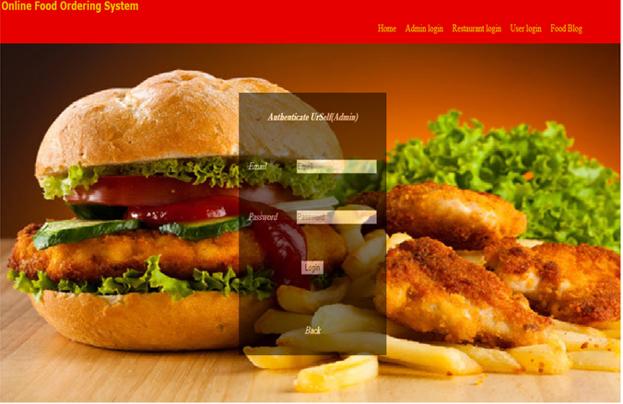

***2.Admin Logged in account***

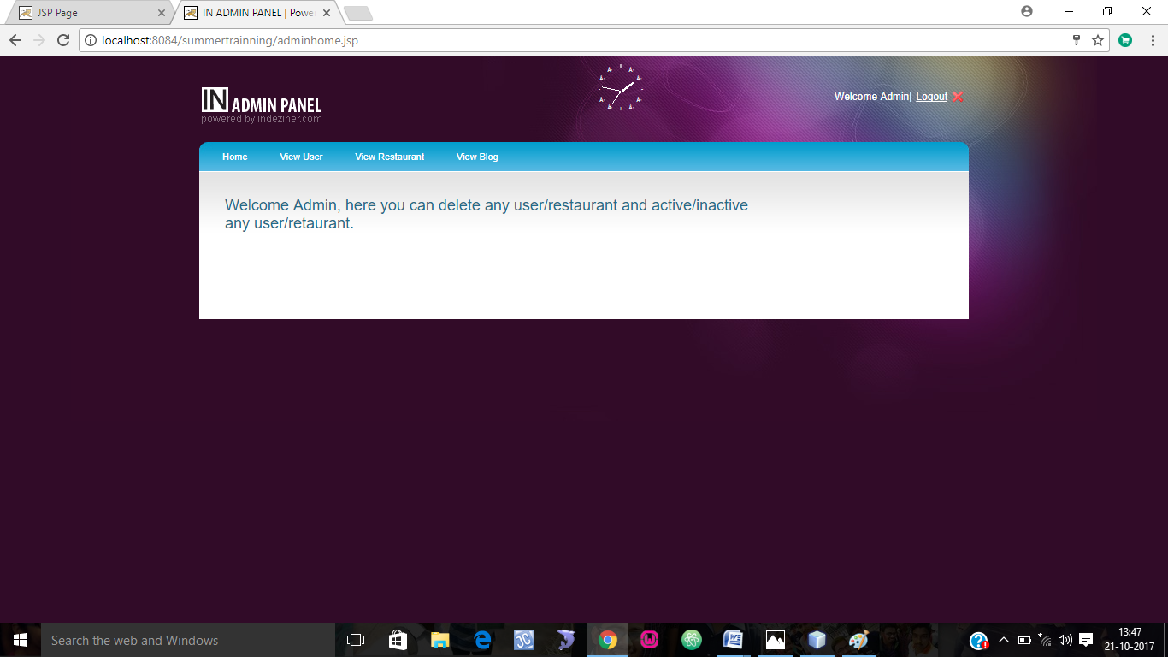

***3.Admin-view user/modify user***

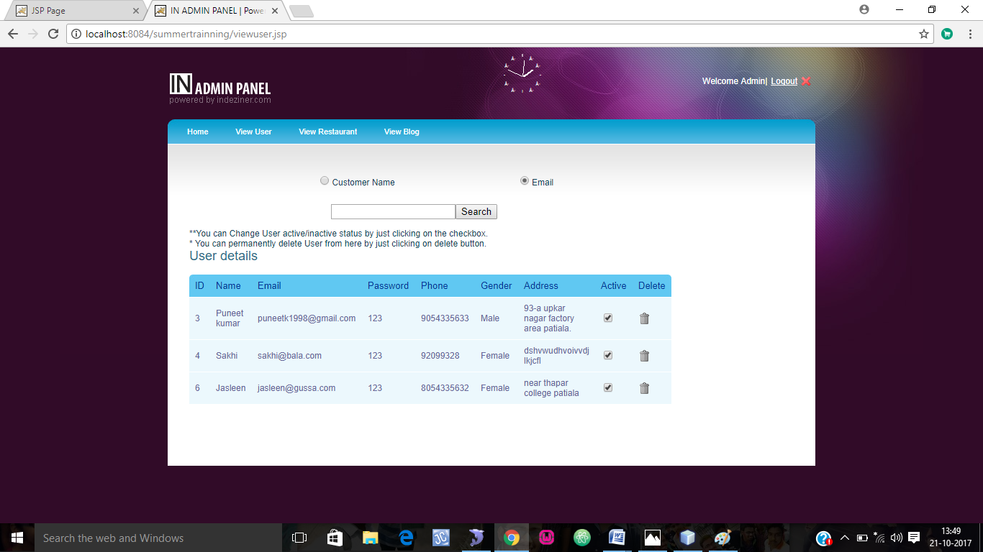

***4.Admin-view Restaurant/Modify***

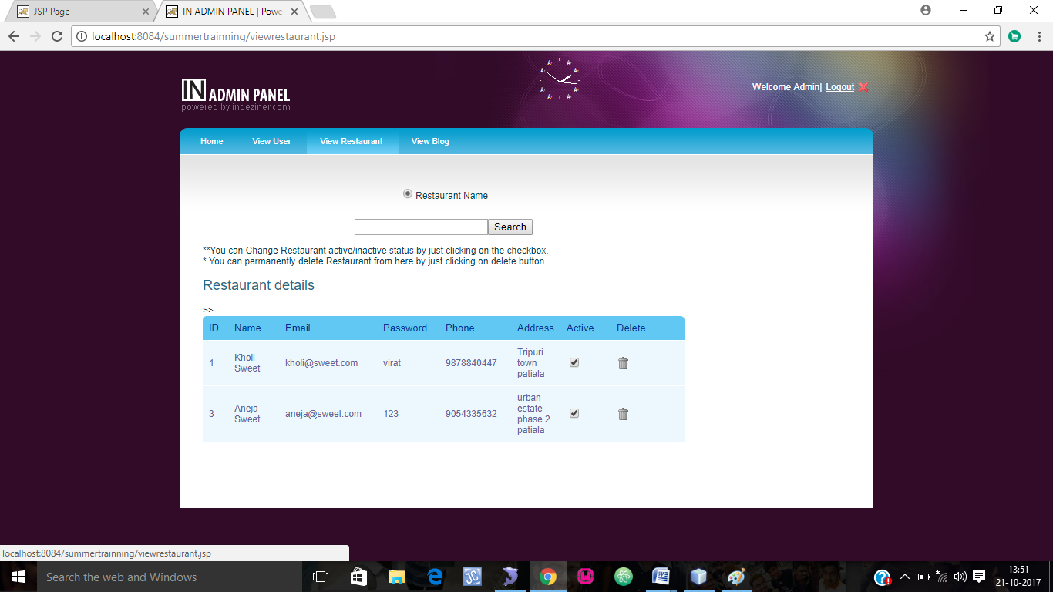

***5.Admin-View Blog/modify***

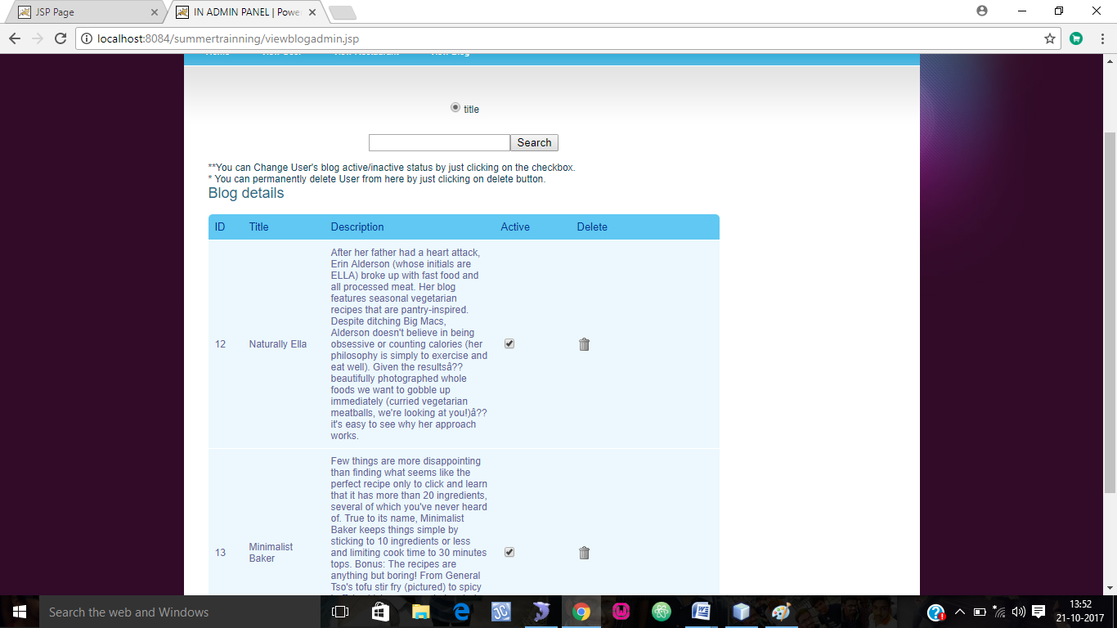

**USER MODULE**

User Module consists of all those pages which have vital information regarding buying & selling of products. It comprises of registration page, Login page, profile page etc.

***1.Home***

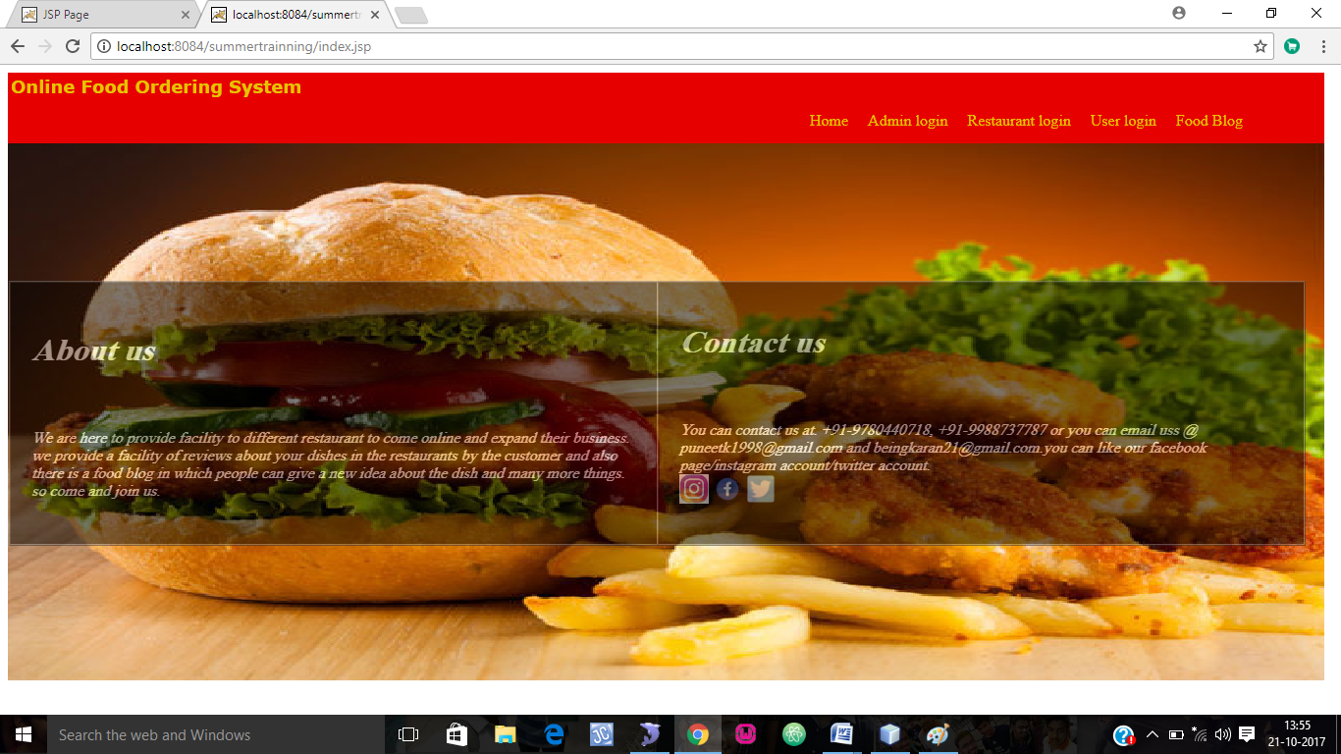

***2. Registration Page*** 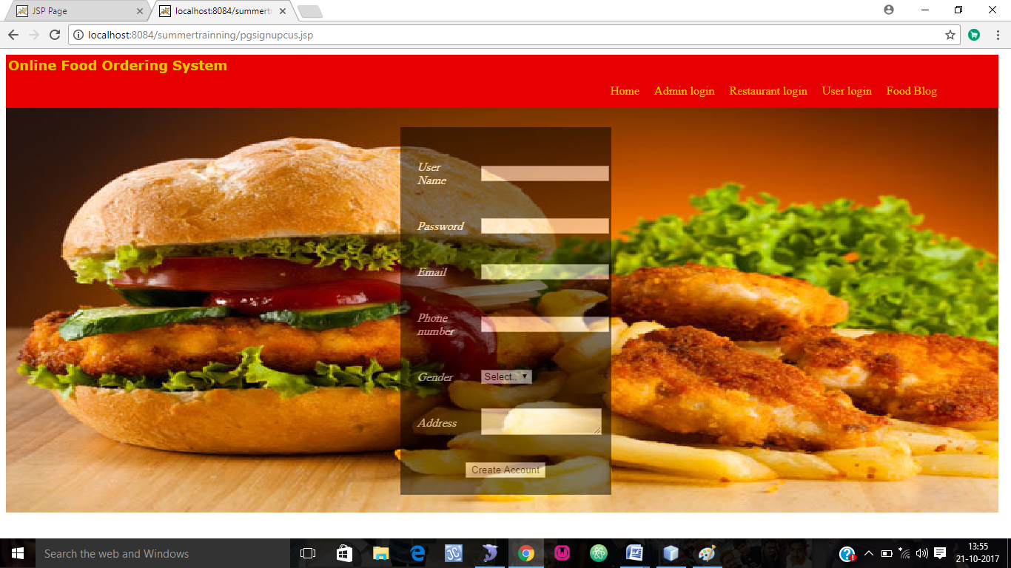

***3. User Login***

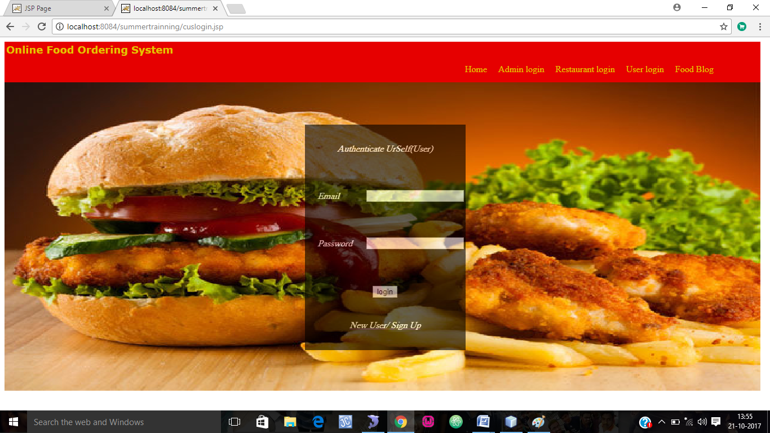

***4. User Logged In***

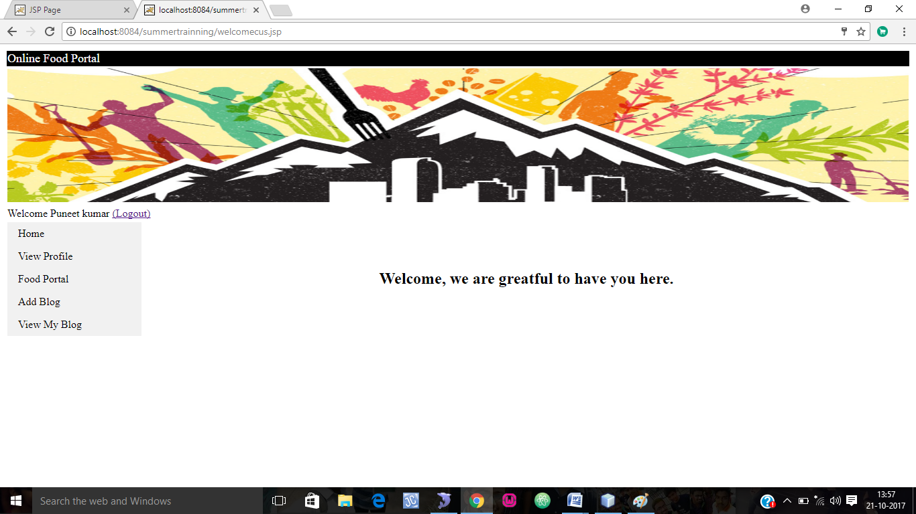

***5.View Profile***

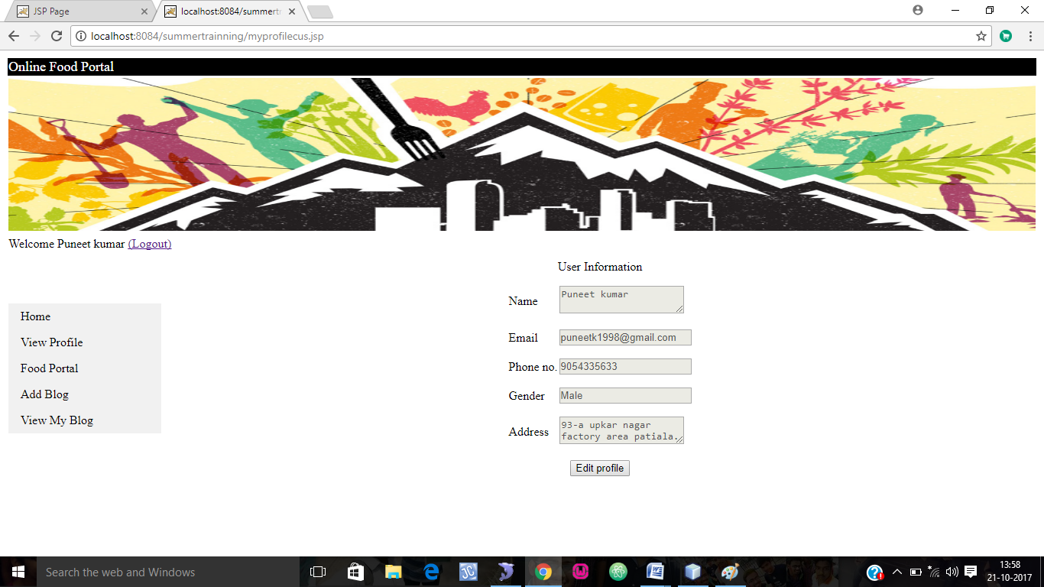

***6. Edit Profile***

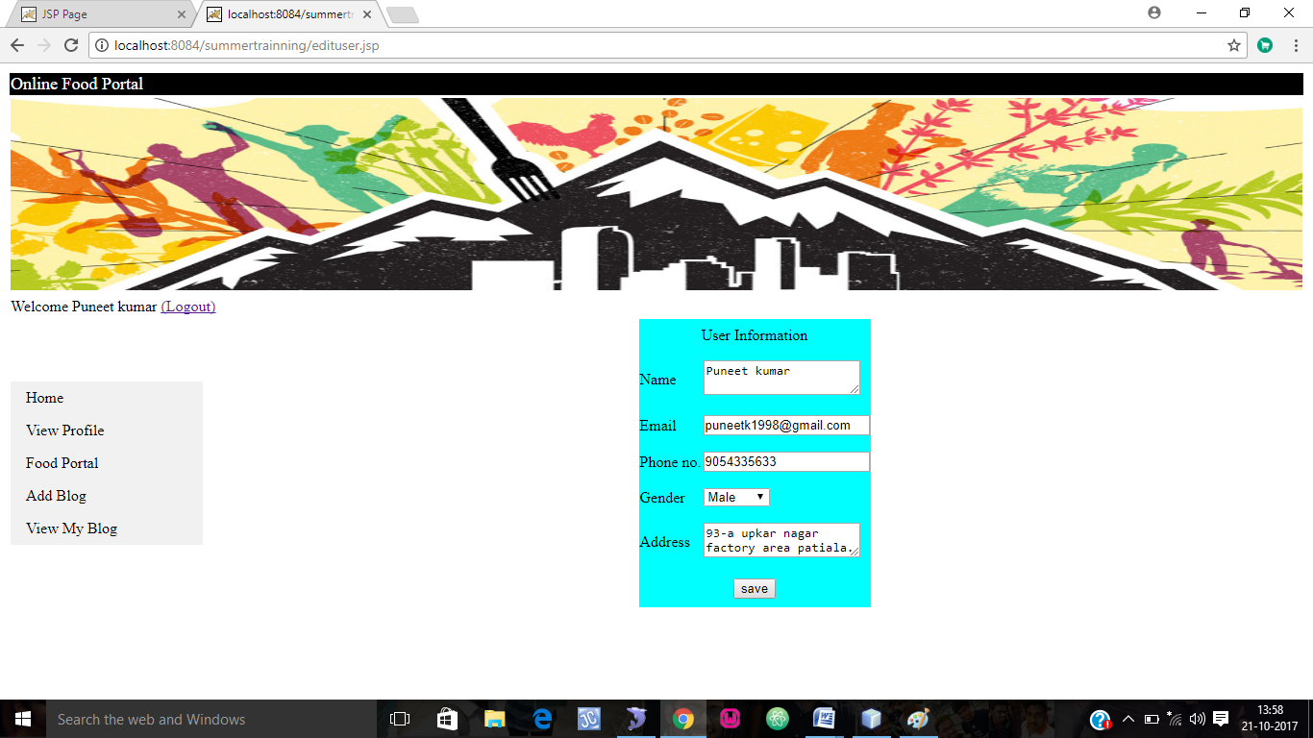

***7. View Restaurant***

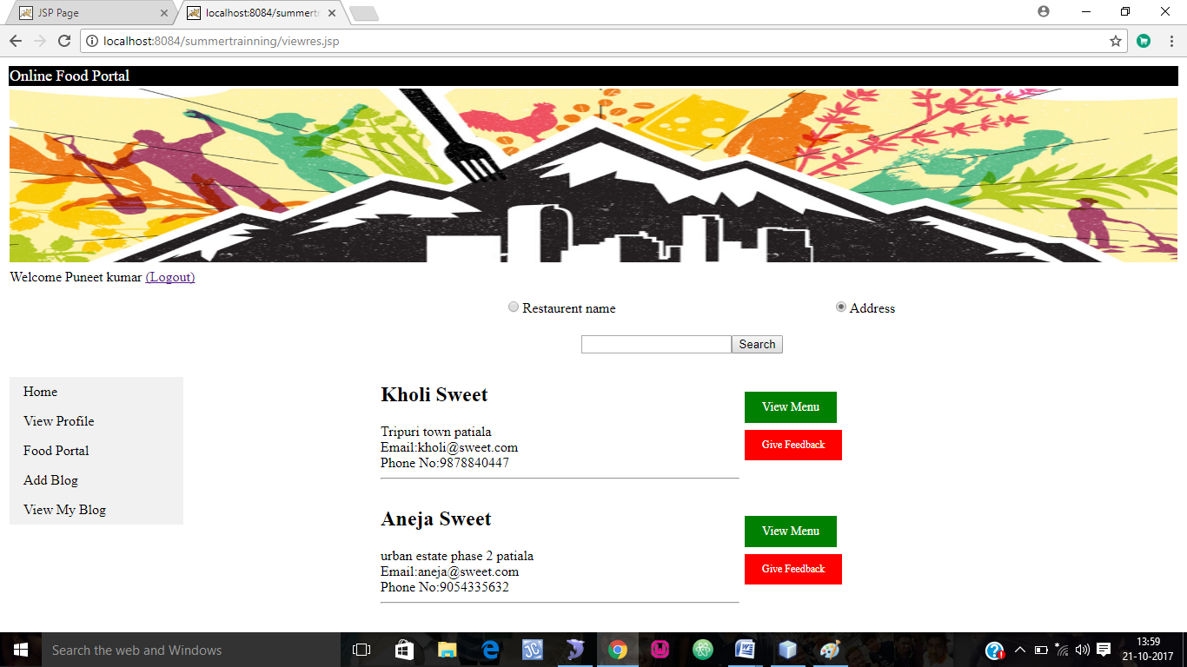

***8. menu and cart***

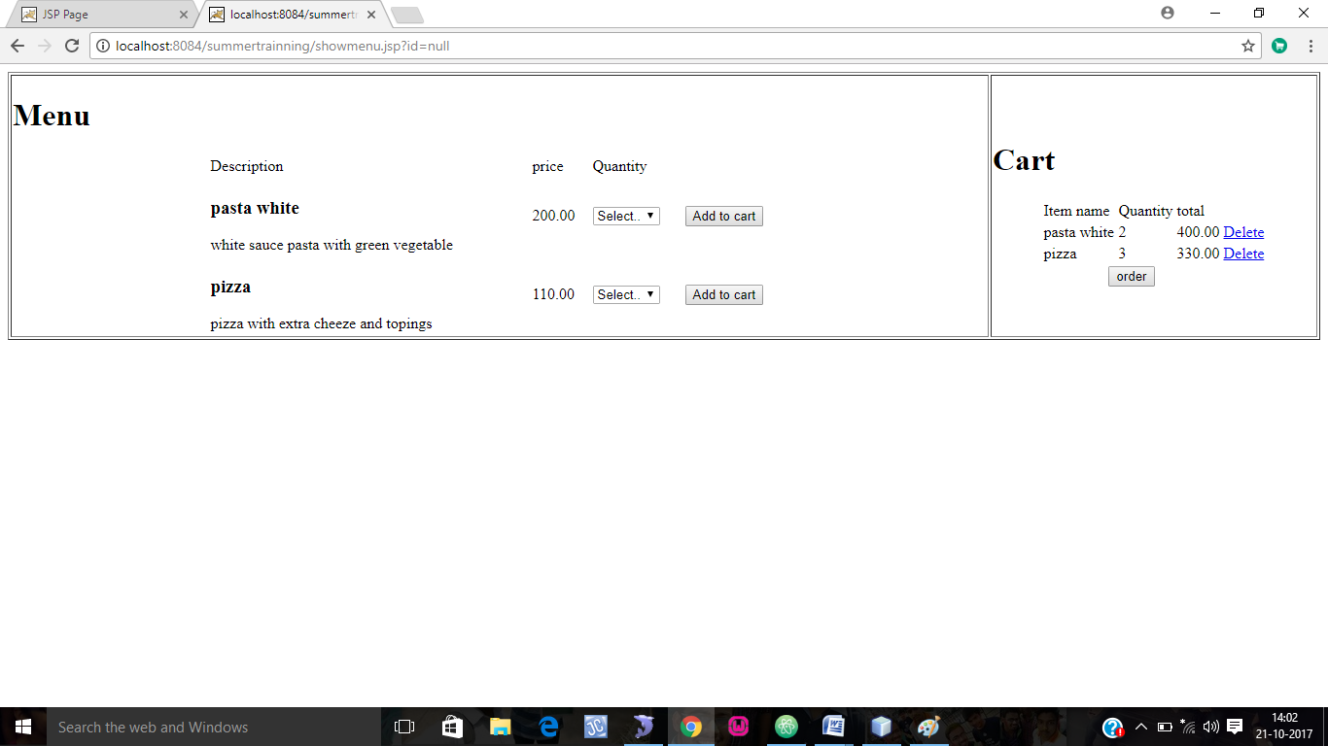

***9. Order*** 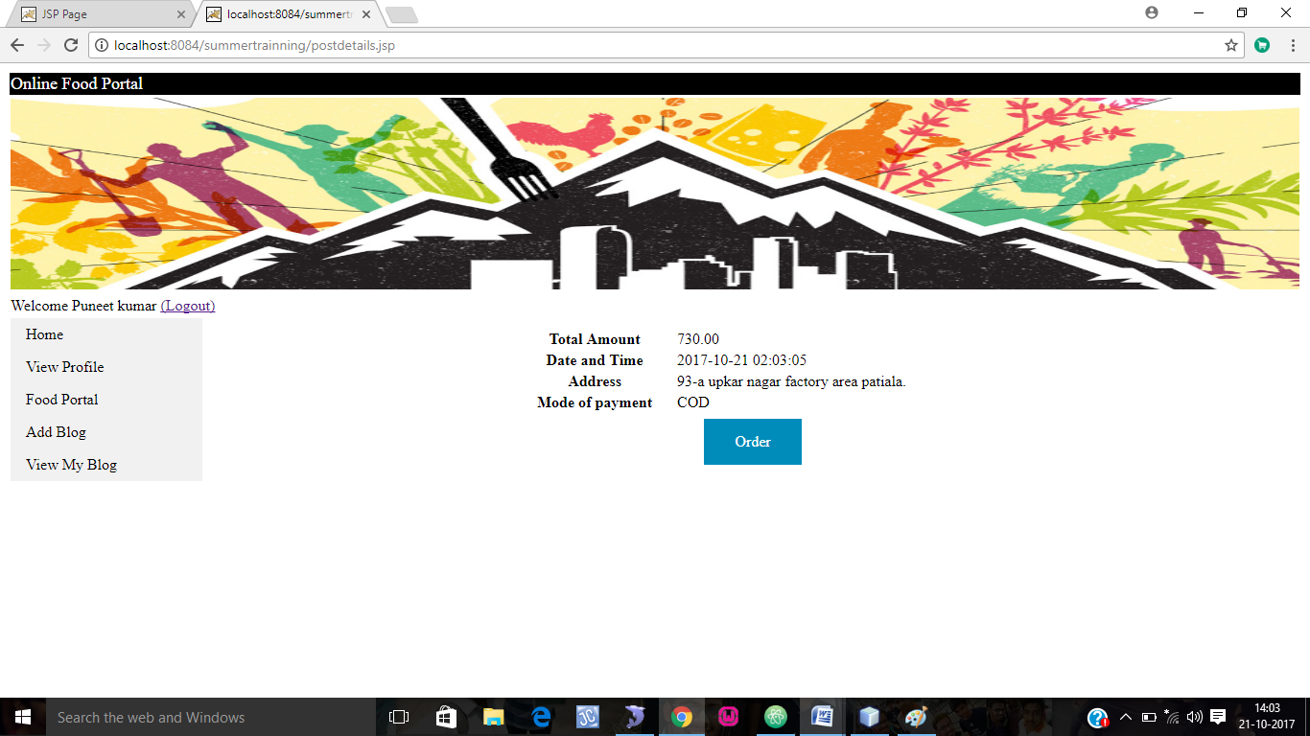

***10. Order Placed***

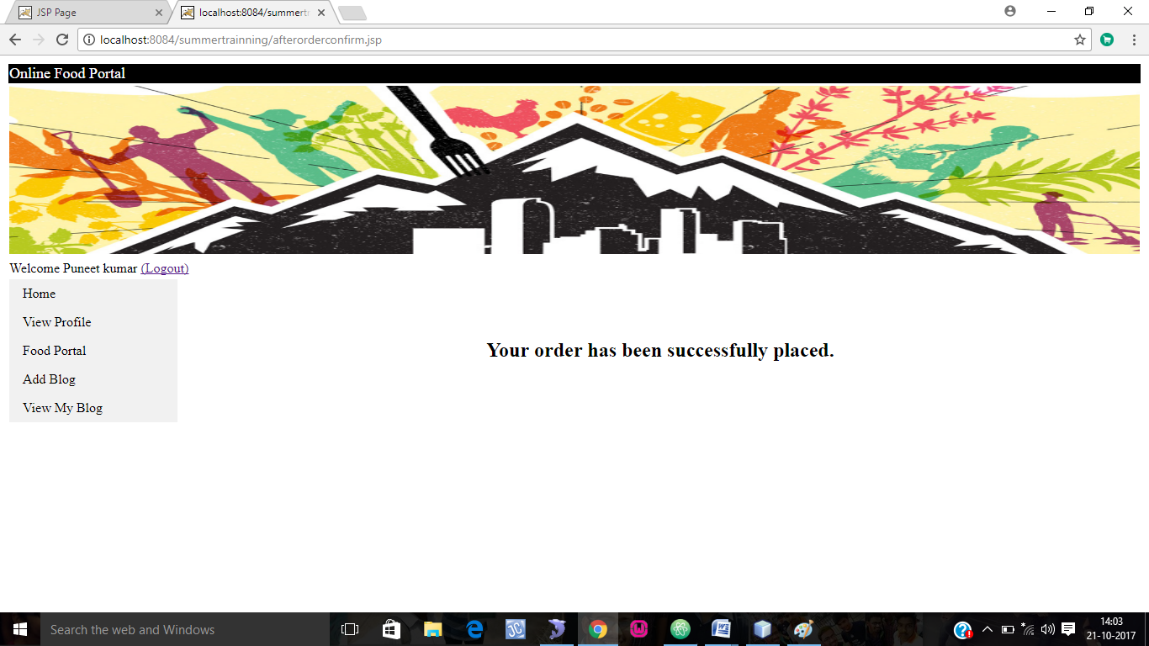

***11.Give feedback***

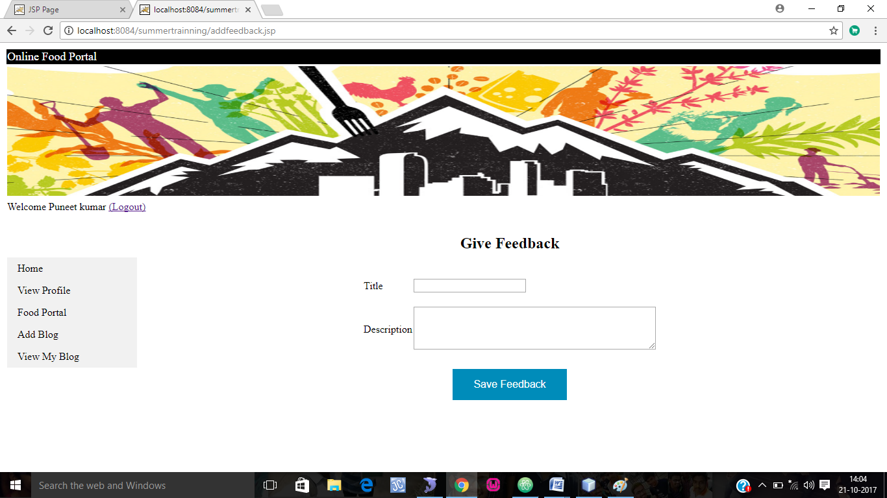

***12. Add blog***

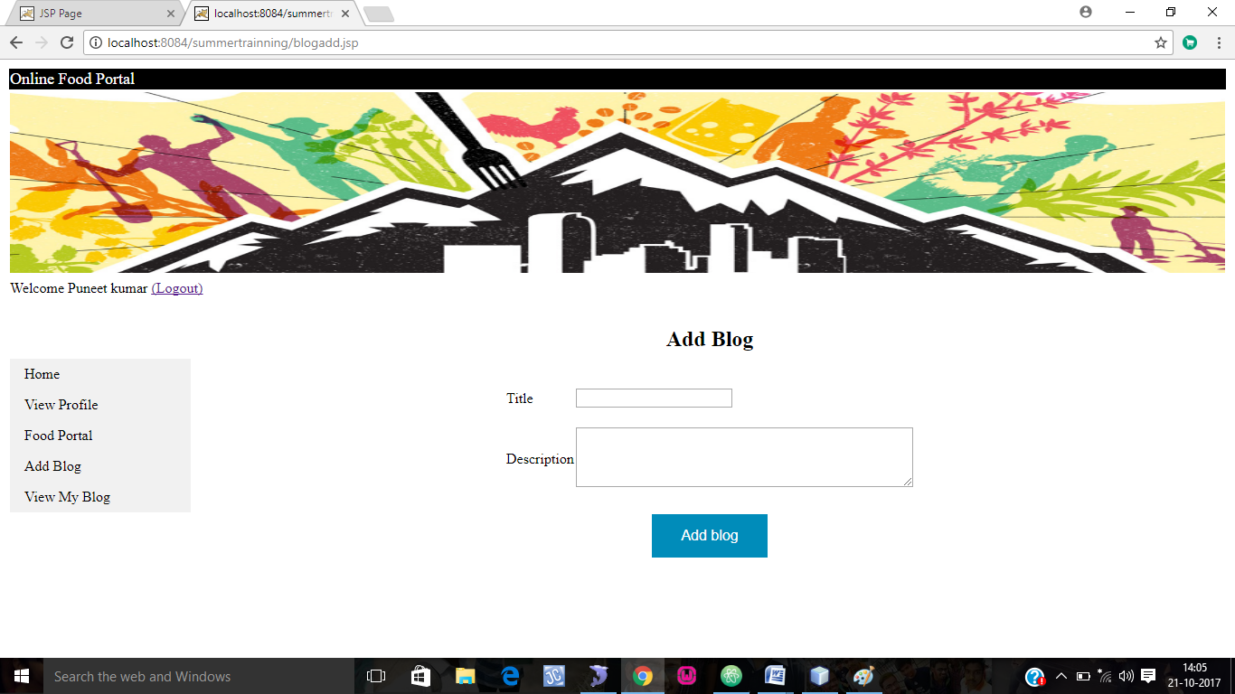

***13.Edit Blog***

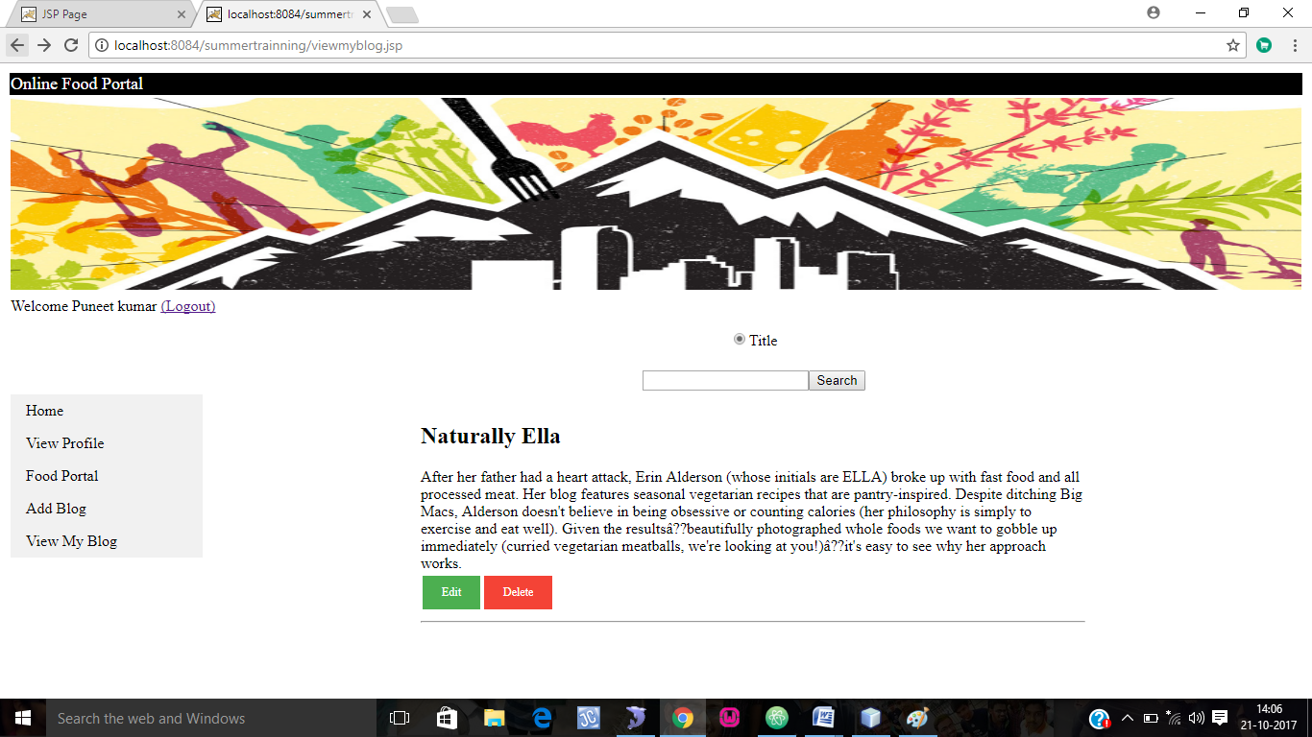

***14.Edit Blog*** 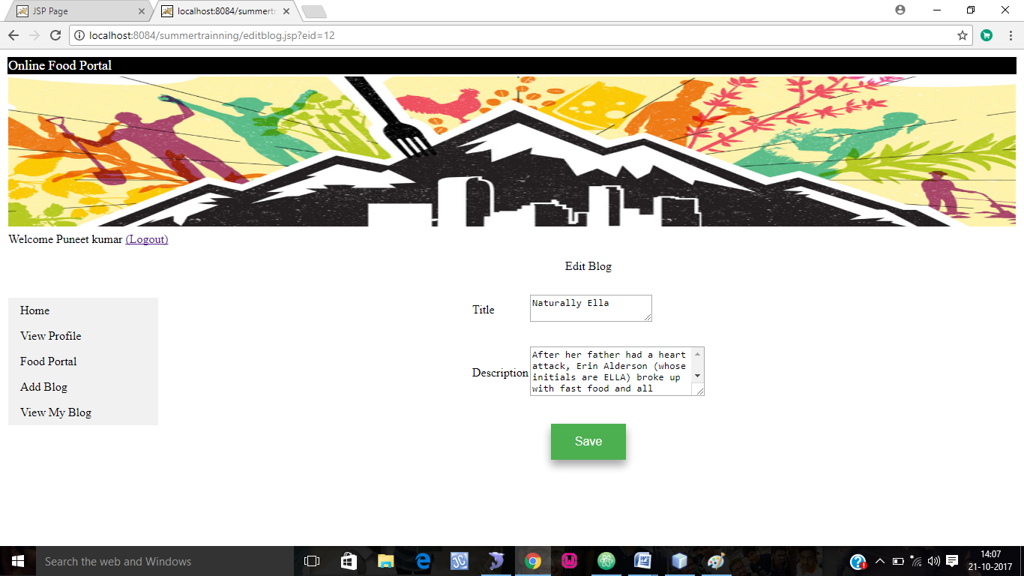

***Restaurant Module***

***1)Restaurant Login***

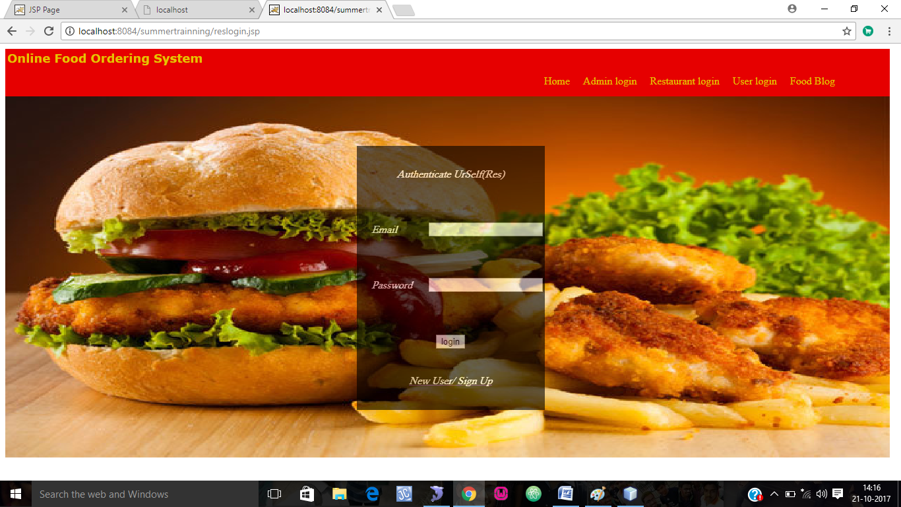

***2)Restaurant logged in***

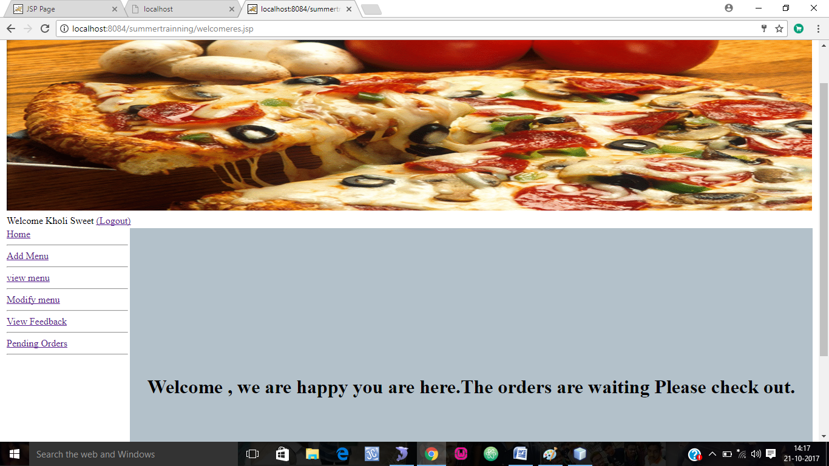

***3)Add Item***

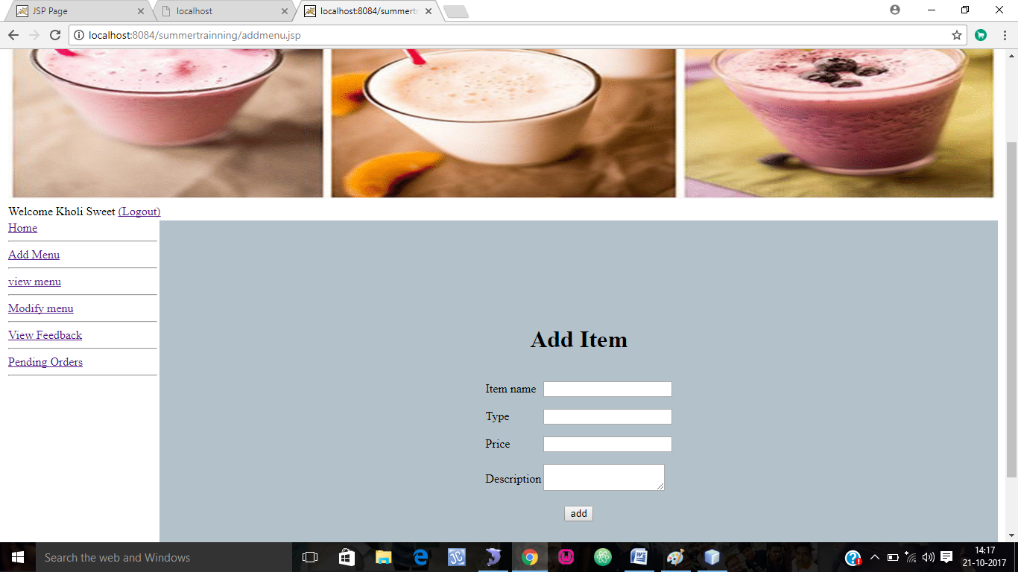

***4)View Menu***

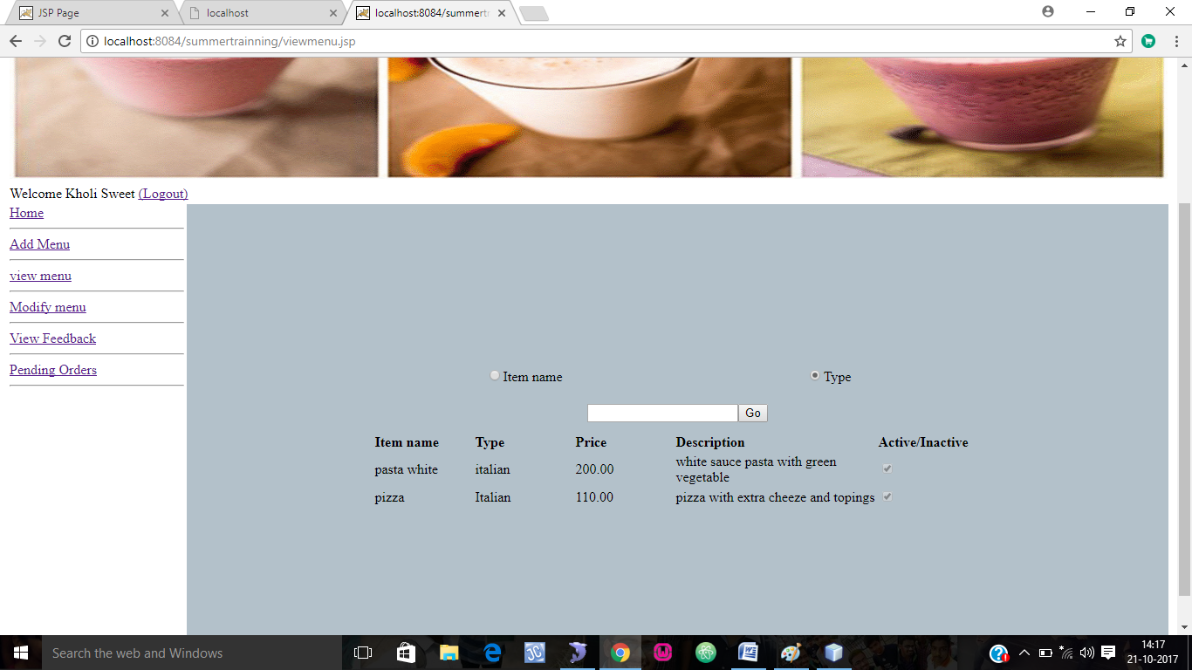

***5)Modify Menu***

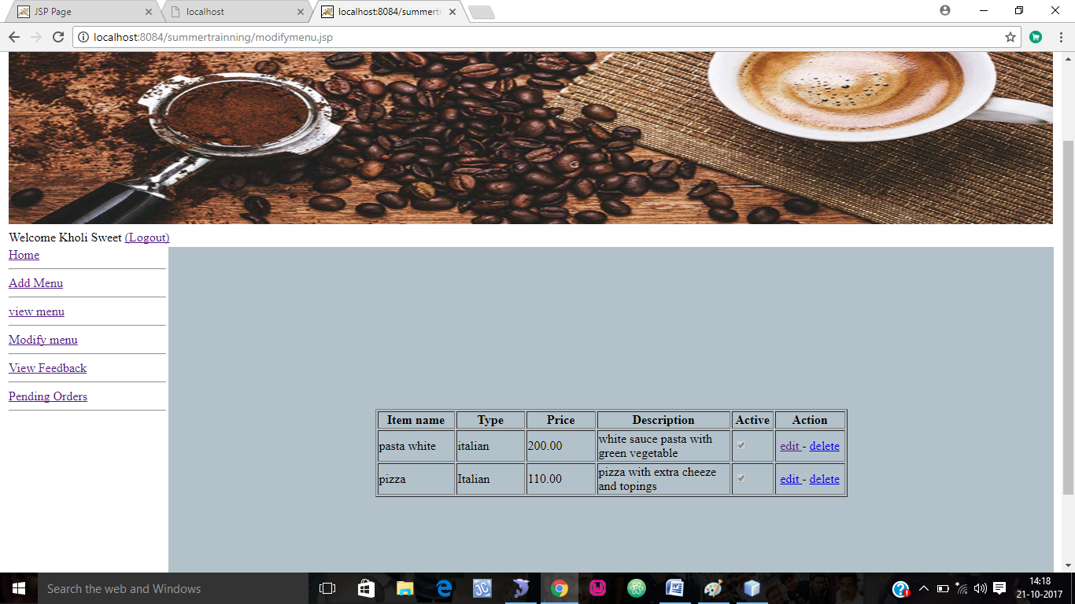

***6)Pending Orders***

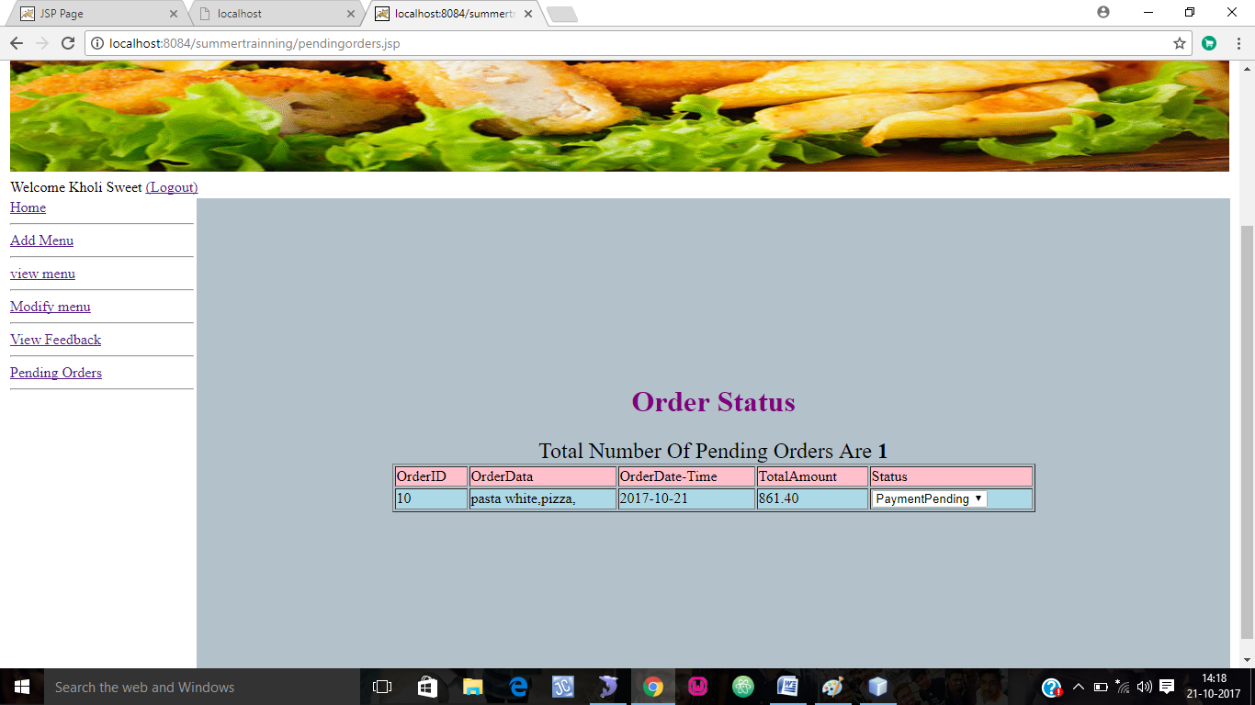

***7)View feedback***

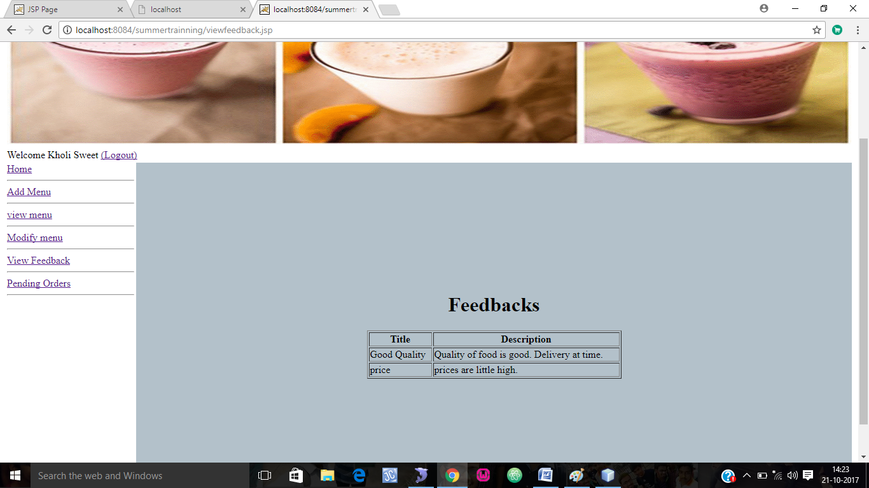

***BACK END SCREENSHOTS***

***1.Database Schema*** 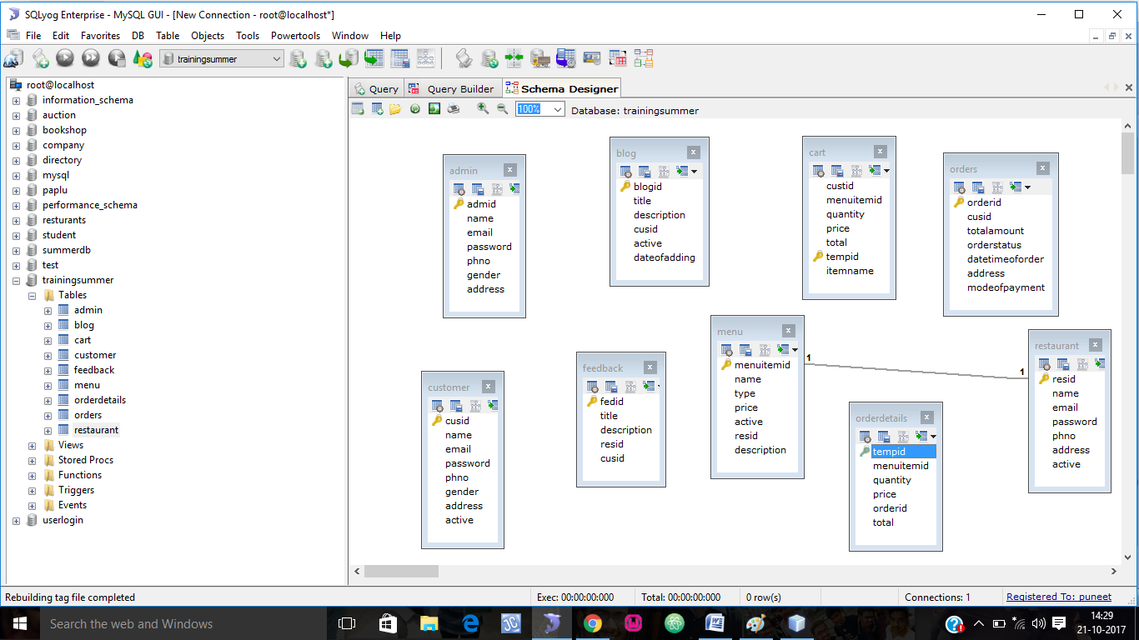

***2. Admin Table***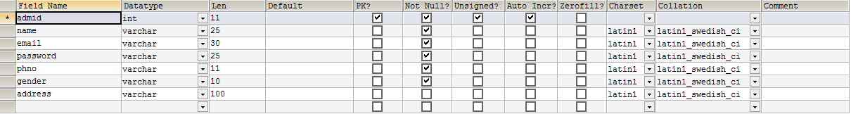

***3. Blog table***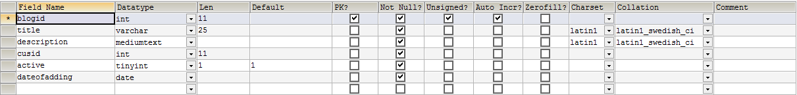

***4. Cart Table***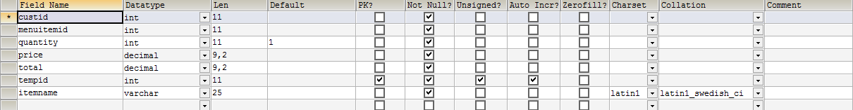

***5 .Customer Table***

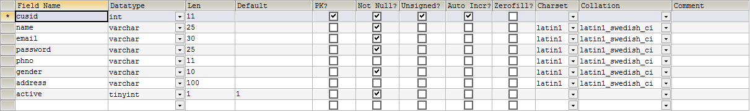

***6. Feedback Table***

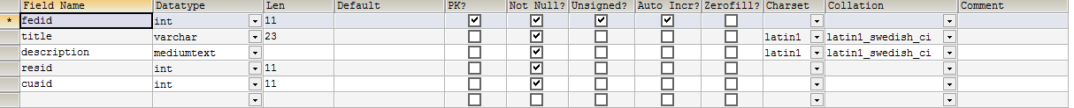

***7. Menu Table***

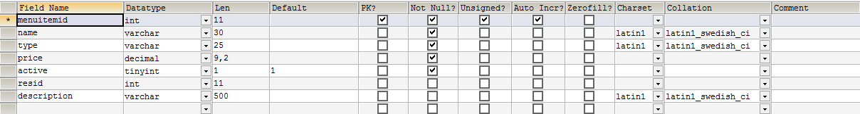

***8.Orderdetails Table***

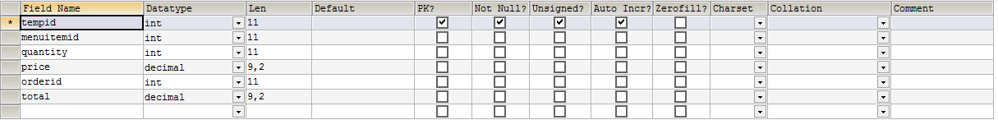

***9.Order table***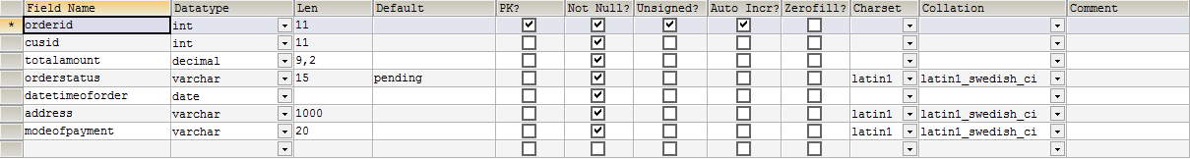

***10.Restaurant Table***

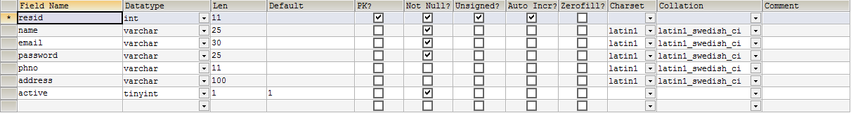

***TESTING***

* **Software Testing Types:**
* **Black box testing:** Internal system design is not considered in this type of testing. Tests are based on requirements and functionality.
* **White box testing:** This testing is based on knowledge of the internal logic of an application’s code. Also known as Glass box Testing. Internal software and code working should be known for this type of testing. Tests are based on coverage of code statements, branches, paths, conditions.
* **Test Cases Designed**
* **New User Signup**

Details are filled using the registration form. (Name, Email, Address and other fields). An appropriate error message is displayed if some field is left empty. Fill in all required fields in correct format. The user should be directed to the confirmation page.

* **Search Products**

Category and Subcategory is selected from the dropdown Lists. Searching is done properly and the result is displayed in the form of a table.

* **Update User Information**

User should be allowed to update his details. Fill in all required fields in correct format. The user information should be updated in the database.

* **Maintain Product Information**

An appropriate error message should be displayed and the user should not be allowed to post the products without the concern of admin. The admin should be directed to the confirmation page.

* **Delete User**

User should not be allowed to delete himself. Admin can delete or block the user. The admin should be directed to the confirmation page.

* **Sending SMS**

If some user forgets his/her password, SMSs are sent to user on their registered mobile number. SMS were not received at contact numbers which are registered under DND(Do Not Disturb).

* **User Login**

An appropriate message is displayed if some field is left empty. An appropriate message is displayed if Username or Password is incorrect. If correct, user is directed to his/her profile.

* **Change Password**

Old and new passwords are confirmed. Appropriate message is displayed if passwords don't match. Else password is updated.

***REQUIREMENT ANALYSIS***

* **Requirement Analysis**

Requirements analysis is critical to the success of a system or software project. The requirements should be documented, actionable, measurable, testable, traceable, related to identified business needs or opportunities, and defined to a level of detail sufficient for system design.

* **Hardware and Software Requirements**
* **Hardware Requirements:**
* Deployment Server

PC: WAMP Server

Processor: Intel Pentium Processor 5, 2.4GHz or above.

RAM: 512 MB RAM

HDD: 40 GB

* End User’s PC

PC: PC (Windows), Windows

Processor: Intel Pentium Processor 5, 233 MHz or equivalent

RAM: 512 Mb RAM

HDD: 500 MB of free HDD space for Internet Cache

Internet Connection: 512 K

* **Software Requirements:**
* Deployment Server

Operating System: Windows

Other software: MySQL Server

Web Server: Apache Tomcat or GlassFish Server

Language compiler: jdk1.5 or above

* End User’s

Operating System: Win 2000 / Win XP or higher Windows

Browser: IE 9, Firefox 12

Active X/ Plug-in: None

***BIBLIOGRAPHY***

* **BOOK REFERENCES:**
* The Complete Reference Java2 by Herbert Schildt
* Class Notes
* Simplified Approach to DBMS by Prateek Bhatia&Gurvinder Singh
* Oracle Database PL/SQL Language Reference, 11*g* Release 1 (11.1) by Ivan Barslow
* **WEB REFERENCES:**
* URL: <http://www.mvayoo.com/>
* URL: <http://www.w3schools.com/>
* URL: <http://www.stackoverflow.com/>